Multicultural Corner with Renee

**Multicultural Corner**

February is Black History Month, Human Rights Month and National Inclusive Education Month.

Check out this website <https://humanrights.ca/>

It provides students and teachers virtual access to the Museum of Human Rights. Its appealing technical design and research tools support the study of the history of human rights in Canada. In particular, teachers may highlight the stories and videos to explore historical and social issues in Canadian society and their place in global relations. Upper-intermediate and secondary students may be encouraged to collect and organize information to support a course of action to address a problem or issue.

**Diversity Equity and Inclusion (DEI) Book**

|  |  |  |
| --- | --- | --- |
|  | **And We Rise**  By: Erica Martin  Published: 2022  Grade: 7+ | A powerful, impactful, eye-opening journey that explores the Civil Rights Movement in 1950s-1960s America in spare and evocative verse, with historical photos interspersed throughout.  In stunning verse and vivid use of white space, Erica Martin's debut poetry collection walks readers through the Civil Rights Movement—from the well-documented events that shaped the nation’s treatment of Black people, beginning with the "Separate but Equal" ruling—and introduces lesser-known figures and moments that were just as crucial to the Movement and our nation's centuries-long fight for justice and equality.  A poignant, powerful, all-too-timely collection that is both a vital history lesson and much-needed conversation starter in our modern world. Complete with historical photographs, author's note, and chronology of events, research, and sources. |

**

February is Black History Month, Human Rights Month and National Inclusive Education Month.

Check out this website for more resources about Black History <https://www.canada.ca/en/canadian-heritage/campaigns/black-history-month.html> that include information about Canadian communities, noteworthy historical figures, and more.

**Diversity Equity and Inclusion (DEI) Book**

|  |  |  |
| --- | --- | --- |
|  | **This Is the Rope: A Story from the Great Migration**  By: Jacqueline Woodson  Illustrated: James Ransome | **February is Black History Month**  The story of one family's journey north during the Great Migration starts with a little girl in South Carolina who finds a rope under a tree one summer. She has no idea the rope will become part of her family's history.  A book selection from The Black Book Project for 2023. |

**February 9th, 2024**

February is Black History Month, Human Rights Month and National Inclusive Education Month.

Check out this website <https://humanrights.ca/>

It provides students and teachers virtual access to the Museum of Human Rights. Its appealing technical design and research tools support the study of the history of human rights in Canada. In particular, teachers may highlight the stories and videos to explore historical and social issues in Canadian society and their place in global relations. Upper-intermediate and secondary students may be encouraged to collect and organize information to support a course of action to address a problem or issue.

**Diversity Equity and Inclusion (DEI) Book**

|  |  |  |
| --- | --- | --- |
|  | **Just Ask! Be Different, Br Brave, Be You**  By: Sonia Sotomayor  Published: 2019  Theme: Inclusion | This book explores the different abilities kids, and people of all ages, have. Using her own experience as a child who was diagnosed with diabetes, Supreme Court Justice Sonia Sotomayor writes about children with all sorts of challenges and looks at the special powers those kids have as well. |

**For January 19, 2024**[](https://www.rickhansen.com/schools-communities/create-inclusive-school-year/concentrate-kindness?utm_source=Email&utm_medium=Referral&utm_campaign=Kate+Outreach&utm_id=Kate+Outreach&utm_content=Kate+inclusive+school+year+individual+outreach+to+contacts)

Did you know the [Multicultural Calendar](https://multiculturalcalendar.com/ecal/index.php?s=c-okanag) can be accessed by all staff on the SD23 Dashboard in the Diversity, Equity and Inclusion tile?

This calendar features special occasions, events and holidays recognized by different communities. Looking ahead to **February**, itis **Black History Month** (click [here](https://bcblackhistory.ca/) for more resources) and **National Inclusive Education Month**. The Rick Hansen Foundation Schools Program has resources available for K-12. View the new Be Kind resources.

English - <https://www.rickhansen.com/schools-communities/resource-library>

French - <https://www.rickhansen.com/fr/ecoles-et-communautes/centre-de-ressources>

**Diversity Equity and Inclusion (DEI) Book**

|  |  |  |
| --- | --- | --- |
|  | **Just Ask! Be Different, Br Brave, Be You**  By: Sonia Sotomayor  Published: 2019  Theme: Inclusion | This book explores the different abilities kids, and people of all ages, have. Using her own experience as a child who was diagnosed with diabetes, Supreme Court Justice Sonia Sotomayor writes about children with all sorts of challenges and looks at the special powers those kids have as well. |

**Dec 15th, 2023**

This calendar features special occasions, events and holidays recognized by different communities. On **Tuesday, December 26, 2023** it is **Kwanzaa**. This is celebrated in the Bahamas. 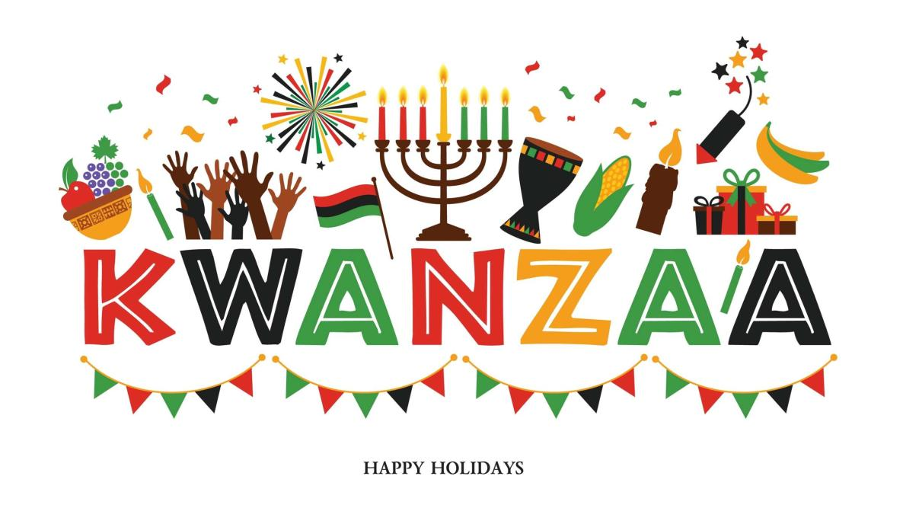

A professor who wanted to encourage African Americans to celebrate their heritage started Kwanzaa's in California in 1966. Kwanzaa means first fruit in Swahili and is a harvest festival. Families exchange gifts and have African style feasts. Seven-pronged candleholders are lit on each consecutive night for the seven principles: unity, self-determination, working together, sharing, purpose, creativity, and faith. The celebration continues till January 1.

Another celebration happening on **Tuesday, December 26, 2023** it is **Junkanoo**.

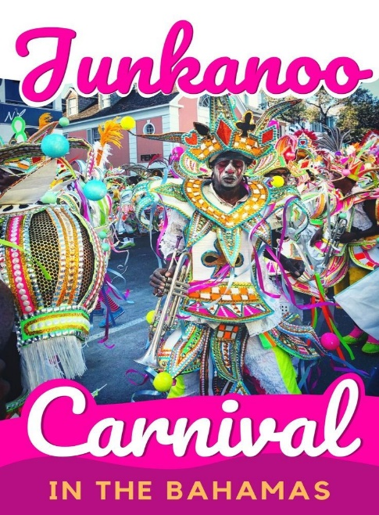

"Junkanoo", is a festival that combines elements of Mardi Gras, mummers' parades, and ancient African tribal rituals and continues on to January 1.



**Nov. 10, 2023**

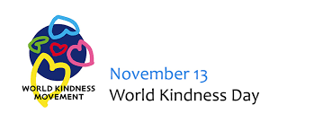

This calendar features special occasions, events and holidays recognized by different communities. **International World Kindness Day** is on **Monday, November 13, 2023**.

The spark for World Kindness Day was lit at the Second Conference of World Kindness Movement in November 1997 in Japan. Starting as random acts of kindness, the movement now has members in over 17 countries including Canada. They are committed to building a global organization dedicated to inspire and promote kindness.

**Nov. 3, 2023**



Did you know the [Multicultural Calendar](https://multiculturalcalendar.com/ecal/index.php?s=c-okanag) can be accessed by all staff on the SD23 Dashboard in the Diversity, Equity and Inclusion tile?

This calendar features special occasions, events and holidays recognized by different communities. **Diwali** this year will start on **November 12, 2023 to November 16, 2023**.

**Diversity Equity and Inclusion (DEI) Book**

|  |  |  |
| --- | --- | --- |
| Amazon.com: Binny's Diwali: 9781338364484: Umrigar, Thrity, Chanani, Nidhi:  Books | **Binny's Diwali**  By: Thrity Umrigar  Illustrated by: Nidhi Chanani  Published: 2020 | Binny woke up happy but nervous. It was her day to share about Diwali, the Festival of Lights!  Binny is excited to talk to her class about her favorite holiday. But she struggles to find the words. Taking a deep breath, she tells her classmates about the fireworks that burst like stars in the night sky, leaving streaks of gold and red and green. She shares with them delicious pedas and jalebis. And she shows them clay lamps, called diyas, which look so pretty all the children ooh and aah. Binny's Diwali is a holiday treat. |

**Oct. 27, 2023**

Did you know the [Multicultural Calendar](https://multiculturalcalendar.com/ecal/index.php?s=c-okanag) can be accessed by all staff on the SD23 Dashboard in the Diversity, Equity and Inclusion tile?

This calendar features special occasions, events and holidays recognized by different communities. **Diwali** this year will start on **November 12, 2023 to November 16, 2023**.

Diwali is Hindu New Year, but also celebrated by Sikhs and Jains, as well as some Muslims and Buddhists. Diwali is known as the festival of lights and is considered as one of India's most celebrated holiday. The holiday lasts for 5 days. Each day has a special meaning. Check out: <https://kids.nationalgeographic.com/pages/article/diwali>

**Oct. 20, 2023**

Did you know the [Multicultural Calendar](https://multiculturalcalendar.com/ecal/index.php?s=c-okanag) can be accessed by all staff on the SD23 Dashboard in the Diversity, Equity and Inclusion tile?

This calendar features special occasions, events and holidays recognized by different communities.

Coming up next month on November 3rd is **Bunka No Hi**. It is a national holiday dedicated to the love of freedom and promotion of Japanese culture.

**Diversity Equity and Inclusion (DEI) Book**

|  |  |  |
| --- | --- | --- |
| C:\Users\rhennata.opperman\AppData\Local\Microsoft\Windows\INetCache\Content.MSO\8E9187E2.tmp | **The Name Jar**  Picture Book  By: Yangseek Choi | Being the new kid in school is hard enough, but what about when nobody can pronounce your name? Having just moved from Korea, Unhei is anxious about fitting in. So instead of introducing herself, she tells the class she will choose a name by the following week. Her classmates are fascinated by this no-name girl and decided to help out by filling a glass jar with names for her to pick from. But while Unhei practices being a Suzy, Laura, or Amanda, one of her classmates discovers her real name and its special meaning. Encouraged by her new friends, Unhei chooses her Korean name and helps everyone pronounce it. |

**Oct. 13, 2023**

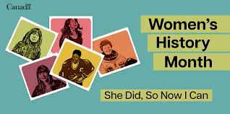This calendar features special occasions, events and holidays recognized by different communities. October is **Canadian Islamic History Month, Latin American Heritage Month,** and **Women's History Month (Canada).**

**Women's History Month (Canada).**

Established in 1992 by the Government of Canada, this special month provides an opportunity to learn more about women’s historic accomplishments and their contributions to Canadian society.

**Diversity Equity and Inclusion (DEI) Book**

|  |  |  |
| --- | --- | --- |
| C:\Users\rhennata.opperman\AppData\Local\Microsoft\Windows\INetCache\Content.MSO\BAD1A35B.tmp | **Malala: My story of standing up for girls' rights**  By Malala Yousafzai, Sarah J. Robbins (Adapted by)  Published: 2018 | A chapter book edition of Nobel Peace Prize winner Malala Yousafzai's bestselling story of courageously standing up for girls' education. Malala's powerful memoir of risking her life for the right to go to school is now abridged and adapted for chapter book readers. |

**Oct 6 2023**

Did you know the [Multicultural Calendar](https://multiculturalcalendar.com/ecal/index.php?s=c-okanag) can be accessed by all staff on the SD23 Dashboard in the Diversity, Equity and Inclusion tile?

This calendar features special occasions, events and holidays recognized by different communities. October is **Canadian Islamic History Month** and

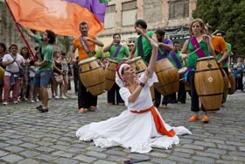**Latin American Heritage Month.**

**Oct. 12** is Day of Respect for Cultural Diversity in Argentina. Known as Dia de la Raza in many South American countries. It celebrates the Hispanic influences on the Americas.

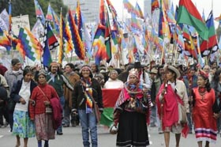

Also on **Oct. 12** in Mexico is Dia de la Raza. This day is to celebrate the Hispanic and Latino heritage in the Americas. 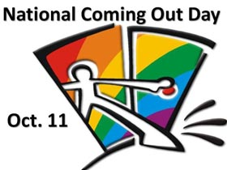

The first National Coming Out Day was held on **Oct. 11**, 1988. It is an international event which gives 2SLGBTQIA+ people the opportunity to celebrate their identities, decrease stigma, increase awareness, and advocate for change.

**Diversity Equity and Inclusion (DEI) Book**

|  |  |  |
| --- | --- | --- |
| Teaching Tough Topics: How do I use children's literature to build a deeper  understanding of social justice, equity, and diversity? | Indigo | **Teaching Tough Topics: How do I Use Children's Literature to Build a Deeper Understanding of Social Justice, Equity, and Diversity?**  By: Larry Swartz  Published: 2020  Professional Text | Shows teachers how to lead students to become caring citizens as they read and respond to quality children's literature. It is organized around topics that can be challenging or sensitive, yet are significant in order to build understanding of social justice, diversity, and equality. The book is rooted in the belief that by using picture books, novels, poetry, and nonfiction selections, teachers can enrich learning with compassion and empathy as their students make connections to the texts, to others, and to the world. |

**Sept 2023**

[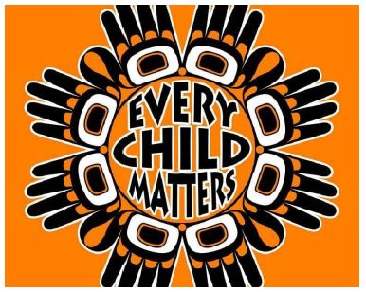](https://www.centralokanaganindigenouseducation.com/orange-shirt-day)Did you know [Indigenous Education](https://www.centralokanaganindigenouseducation.com/) can be accessed by all staff on the SD23 Dashboard in the Diversity, Equity and Inclusion tile?

This link features information about programs, staff, resources (videos, activities, booklists, information and links), and a current calendar of events. Every **September 30th** is [Orange Shirt Day](https://www.centralokanaganindigenouseducation.com/orange-shirt-day)**.** The day officially began in 2013, based on Phyllis Webstad's story in 1973, when she was six-years old. The initiative calls for every Canadian to wear an [**orange shirt**](https://www.centralokanaganindigenouseducation.com/orange-shirt-day) on September 30, in the spirit of healing and reconciliation.

**Diversity Equity and Inclusion (DEI) Book**

|  |  |  |
| --- | --- | --- |
| C:\Users\rhennata.opperman\AppData\Local\Microsoft\Windows\INetCache\Content.MSO\B74D1E47.tmp | **The Orange Shirt Story**  By: Phyllis Webstad  Illustrator: Brock Nicol  2018  Grade 2 and up | When Phyllis Webstad (nee Jack) turned six, she went to the residential school for the first time. On her first day at school, she wore a shiny orange shirt that her Granny had bought for her, but when she got to the school, it was taken away and never returned. This is the true story of Phyllis and her orange shirt. It is also the story of Orange Shirt Day, an important day of remembrance for all Canadians. |
| C:\Users\rhennata.opperman\AppData\Local\Microsoft\Windows\INetCache\Content.MSO\A51D7489.tmp | L’histoire du chandail orange est l’histoire de Phyllis dans ses propres mots, puisqu’elle se souvient vivement de l’événement. En fait, l’histoire se lit presque comme si un enfant la racontait à un autre enfant, ce qui aide les élèves à se sentir interpellé(e)s et connecté(e)s à son histoire. Mme Webstad a fait un enregistrement audio de son livre et nous recommandons vivement de mettre la main dessus puisque cela rend son histoire encore plus convaincante et puissante (anglais seulement). Ce récit est l’histoire derrière la Journée du chandail orange. Il pourrait être utilisé à la place des vidéos suggérées plus tôt ou en plus des vidéos. Si vous n’arrivez pas à accéder à l’audio de Phyllis récitant son histoire, nous suggérons de montrer au moins une des vidéos pour que les enfants aient une idée de la personnalité douce, authentique et sans prétention de Mme Webstad. | |

**May 2023**

This calendar features special occasions, events and holidays recognized by different communities.

December 2002 the Senate of Canada passed a motion designating May as Asian Heritage Month. Canadians take part in festivities commemorating the legacy of Asian Canadians and their many contributions which have helped Canada become the multicultural and diverse nation it is today. For resources and materials, check out: <https://www.canada.ca/en/canadian-heritage/campaigns/asian-heritage-month.html>

**Diversity Equity and Inclusion (DEI) Book**

|  |  |  |  |
| --- | --- | --- | --- |
| **C:\Users\rhennata.opperman\AppData\Local\Microsoft\Windows\INetCache\Content.MSO\4385853C.tmp** | **I’m New Here**  Picture book    by Anne Sibley O'Brien  Published: 2018 | |  | | --- | | Three students are immigrants from Guatemala, Korea, and Somalia and have trouble speaking, writing, and sharing ideas in English in their new elementary school. Through self-determination and with encouragement from their peers and teachers, the students learn to feel confident and comfortable in their new school without losing a sense of their home country, language, and identity. | |

**Multicultural Corner**

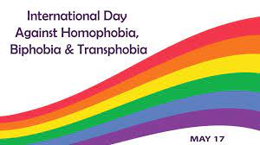Did you know the [Multicultural Calendar](https://multiculturalcalendar.com/ecal/index.php?s=c-okanag) can be accessed by all staff on the SD23 Dashboard in the Diversity, Equity and Inclusion tile?

This calendar features special occasions, events and holidays recognized by different communities.

International Day Against Homophobia, Biphobia, and Transphobia is observed every May 17th. It is to raise awareness on the rights violations of the 2SLGBTQ+ communities. This year on **Wednesday, May 17th, 2023** please **wear a purple shirt** to show your support for 2SLGBTQ+ people.

**Diversity Equity and Inclusion (DEI) Book**

|  |  |  |  |  |
| --- | --- | --- | --- | --- |
|  | |  | | --- | | Love is Love  By Michael Genhart  This gentle story explores the concept of discrimination with regard to family members who are gay. It begins with a young boy being harassed because he wore a t-shirt with a rainbow in honour of his two dads. He is told that his shirt is gay and that his family isn’t real. | | |  | | --- | | Suitable for all grades  Provides opportunities to explore and discuss:  • Similarities and differences  • Acceptance and belonging  • What makes a family a family  • Discrimination / Bullying  • Pride  • Love | |

**April, 2023**

This calendar features special occasions, events and holidays recognized by different communities.

December 2002 the Senate of Canada passed a motion designating May as Asian Heritage Month. Canadians take part in festivities commemorating the legacy of Asian Canadians and their many contributions which have helped Canada become the multicultural and diverse nation it is today. For resources and materials, check out: <https://www.canada.ca/en/canadian-heritage/campaigns/asian-heritage-month.html>

**Diversity Equity and Inclusion (DEI) Book**

|  |  |  |
| --- | --- | --- |
|  | **Kumo: The Bashful Cloud**  Picture book  by **Kyo Maclear**    Published: 2022 | Kumo (which means “cloud” in Japanese) is a touching fable written about a cloud who wants nothing more than to float in the corners of the sky unnoticed. She prefers to “remain soft and invisible,” but when there’s a problem in the sky and the other clouds are unable to help, Kumo is called upon to do her cloud duty: drift, give shelter, and provide rain. She must face her fear of not being enough and grow confident in all she offers.  Selection from the Black Bookshelf Project 2023 |

**April, 2023**

**Multicultural Corner**

Did you know the [Multicultural Calendar](https://multiculturalcalendar.com/ecal/index.php?s=c-okanag) can be accessed by all staff on the SD23 Dashboard in the Diversity, Equity and Inclusion tile?

This calendar features special occasions, events and holidays recognized by different communities.

In 2013, history was made with April proclaimed as Sikh Heritage Month by the Legislative Assembly of Ontario. A variety of lesson plans from K-grade 10 for Sikh Heritage Month can be found here at <https://docs.google.com/presentation/d/e/2PACX-1vT3zuYD1yc3HxDS4S0StxQOiP9lwKNvwnRuBIQhnAODHv7htXicDtn2RDYdjqOKcvC1vV8NworyvaAV/pub?start=false&loop=false&delayms=3000&slide=id.g22666d470ff_0_1>

**Diversity Equity and Inclusion (DEI) Book**

|  |  |  |
| --- | --- | --- |
|  | **Zonia's Rainforest**  Picture book  by **Juana Martinez-Neal**    Published: 2021 | Zonia’s Rainforest takes a beautiful look at a young girl’s life and her determination to save her home. This book follows the story of a young Indigenous girl who stumbles upon a patch of land that has been a victim of deforestation. Frightened, she decides she must answer the call to protect her home.  Selection from the Black Bookshelf Project 2023 |

**March 10, 2023**

Did you know the [Multicultural Calendar](https://multiculturalcalendar.com/ecal/index.php?s=c-okanag) can be accessed by all staff on the SD23 Dashboard in the Diversity, Equity and Inclusion tile?

This calendar features special occasions, events and holidays recognized by different communities.

Ramadan is the ninth month of the Islamic calendar, observed by Muslims worldwide. It starts on **March 23.** During this time, observing Muslims fast between the hours of sunrise and sunset for an entire month, read the Qu'ran and worship in the mosque or at home.

**Diversity Equity and Inclusion (DEI) Book**

|  |  |  |
| --- | --- | --- |
|  | **Other Words for Home**  By: Jasmine Warga  Published: 2021  Fiction  Middle School and older as a class-wide, literature circles or as an independent novel. | Jude is a Muslim Syrian girl navigating a new life in America, a country where she does not feel welcome because of her background and hijab. She learns to fend for herself as she enters 7th grade, and she eventually finds a friend to whom she can relate. A story that highlights obstacles of integrating into a new country as a refugee, the terror of being separated from family, and what identity means to a young girl.  This novel may inspire readers to expand their understanding or heritage, beliefs, and perspectives. |

**February 10, 2023**

**Multicultural Corner**

February is Black History Month, Human Rights Month and National Inclusive Education Month.

Check out this website <https://humanrights.ca/>

It provides students and teachers virtual access to the Museum of Human Rights. Its appealing technical design and research tools support the study of the history of human rights in Canada. In particular, teachers may highlight the stories and videos to explore historical and social issues in Canadian society and their place in global relations. Upper-intermediate and secondary students may be encouraged to collect and organize information to support a course of action to address a problem or issue.

**Diversity Equity and Inclusion (DEI) Book**

|  |  |  |
| --- | --- | --- |
|  | **Just Ask! Be Different, Br Brave, Be You**  By: Sonia Sotomayor  Published: 2019  Theme: Inclusion | This book explores the different abilities kids, and people of all ages, have. Using her own experience as a child who was diagnosed with diabetes, Supreme Court Justice Sonia Sotomayor writes about children with all sorts of challenges and looks at the special powers those kids have as well. |

**February 3, 2023** 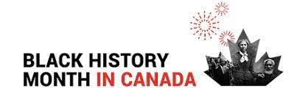

Did you know the [Multicultural Calendar](https://multiculturalcalendar.com/ecal/index.php?s=c-okanag) can be accessed by all staff on the SD23 Dashboard in the Diversity, Equity and Inclusion tile?

This calendar features special occasions, events and holidays recognized by different communities. **February** is **Black History Month.** Visit <https://www.canada.ca/en/canadian-heritage/campaigns/black-history-month.html> for more resources.

**Diversity Equity and Inclusion (DEI) Book**

**January 27, 2023**

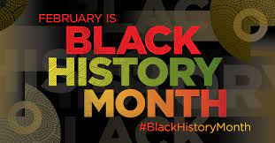

Did you know the [Multicultural Calendar](https://multiculturalcalendar.com/ecal/index.php?s=c-okanag) can be accessed by all staff on the SD23 Dashboard in the Diversity, Equity and Inclusion tile?

This calendar features special occasions, events and holidays recognized by different communities. **February** is **Black History Month.** Click [here](https://bcblackhistory.ca/) for more resources.

In December of 1995, the Parliament of Canada recognized February as Black History Month following a motion introduced by the first African Canadian woman elected to Parliament, Jean Augustine.

**January 20, 2023** [](https://www.rickhansen.com/schools-communities/create-inclusive-school-year/concentrate-kindness?utm_source=Email&utm_medium=Referral&utm_campaign=Kate+Outreach&utm_id=Kate+Outreach&utm_content=Kate+inclusive+school+year+individual+outreach+to+contacts)

Did you know the [Multicultural Calendar](https://multiculturalcalendar.com/ecal/index.php?s=c-okanag) can be accessed by all staff on the SD23 Dashboard in the Diversity, Equity and Inclusion tile?

This calendar features special occasions, events and holidays recognized by different communities. Looking ahead to **February**, itis **Black History Month** (click [here](https://bcblackhistory.ca/) for more resources) and **National Inclusive Education Month**. The Rick Hansen Foundation Schools Program has resources available for K-12. View the new [Be Kind](https://can01.safelinks.protection.outlook.com/?url=https%3A%2F%2Fbcssa.us14.list-manage.com%2Ftrack%2Fclick%3Fu%3D685981bdc9892300aacf66bb6%26id%3D8a504e1697%26e%3Df4550f368e&data=05%7C01%7Crenee.opperman%40sd23.bc.ca%7Cfe9e8803456f4adb795308daf57e246f%7Ca88c6e7e8efc4bc7956fe8170457f178%7C0%7C0%7C638092219374686821%7CUnknown%7CTWFpbGZsb3d8eyJWIjoiMC4wLjAwMDAiLCJQIjoiV2luMzIiLCJBTiI6Ik1haWwiLCJXVCI6Mn0%3D%7C3000%7C%7C%7C&sdata=tveCL83LhQwS9GmOmy3IQP8EZw9D8l2SHoWy1nSud3A%3D&reserved=0) resources.

**January 6, 2023** [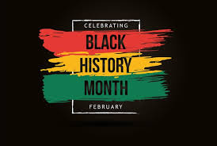](https://bcblackhistory.ca/)

Did you know the [Multicultural Calendar](https://multiculturalcalendar.com/ecal/index.php?s=c-okanag) can be accessed by all staff on the SD23 Dashboard in the Diversity, Equity and Inclusion tile?

This calendar features special occasions, events and holidays recognized by different communities. February is [**Black History Month**](https://bcblackhistory.ca/)**.**

Funded by the Ministry of Education, the Anti-Racism Project goal is to identify and/or develop BC-specific resources aligned with BC’s K-12 curriculum that improve the representation of racialized communities and promote a more comprehensive understanding of anti-racism, human rights, and diverse cultural experiences, histories, and contribution. Black History Month resources can be found [here](https://bcblackhistory.ca/).

**January 13, 2023** [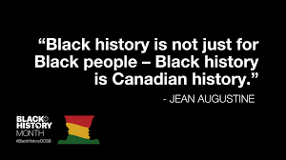](https://bcblackhistory.ca/)

This calendar features special occasions, events and holidays recognized by different communities. **February** is **Black History Month.** Click [here](https://bcblackhistory.ca/) for more resources.

In December of 1995, the Parliament of Canada recognized February as Black History Month following a motion introduced by the first African Canadian woman elected to Parliament, Jean Augustine.

**November 10, 2022** 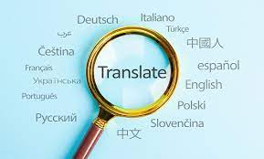

Did you know that the third week in November is Multicultural week in SD#23?

You can impress your students by using [PowerPoint](https://can01.safelinks.protection.outlook.com/?url=https%3A%2F%2Fwww.instagram.com%2Freel%2FCijCxzTD1Ef%2F%3Figshid%3DMDJmNzVkMjY%3D&amp;data=05%7C01%7Crenee.opperman%40sd23.bc.ca%7C65fab9f5eeb3463a845d08dab4aa33a6%7Ca88c6e7e8efc4bc7956fe8170457f178%7C0%7C0%7C638020940348199604%7CUnknown%7CTWFpbGZsb3d8eyJWIjoiMC4wLjAwMDAiLCJQIjoiV2luMzIiLCJBTiI6Ik1haWwiLCJXVCI6Mn0%3D%7C3000%7C%7C%7C&amp;sdata=bptUlI%2FVunBjXfdwXqJaSmFY%2BRRtnIUVW%2BzQfa2ZoaI%3D&amp;reserved=0) to translate documents into multiple languages. Click [here](https://can01.safelinks.protection.outlook.com/?url=https%3A%2F%2Fwww.instagram.com%2Freel%2FCijCxzTD1Ef%2F%3Figshid%3DMDJmNzVkMjY%3D&amp;data=05%7C01%7Crenee.opperman%40sd23.bc.ca%7C65fab9f5eeb3463a845d08dab4aa33a6%7Ca88c6e7e8efc4bc7956fe8170457f178%7C0%7C0%7C638020940348199604%7CUnknown%7CTWFpbGZsb3d8eyJWIjoiMC4wLjAwMDAiLCJQIjoiV2luMzIiLCJBTiI6Ik1haWwiLCJXVCI6Mn0%3D%7C3000%7C%7C%7C&amp;sdata=bptUlI%2FVunBjXfdwXqJaSmFY%2BRRtnIUVW%2BzQfa2ZoaI%3D&amp;reserved=0) to learn how!

Do you have students that speak multiple languages? Have you tried [Microsoft Lens](https://can01.safelinks.protection.outlook.com/?url=https%3A%2F%2Fyoutu.be%2FFg25b8MD030&amp;data=05%7C01%7Crenee.opperman%40sd23.bc.ca%7C5ae559aa7d5e4dd5645908dab4a85a27%7Ca88c6e7e8efc4bc7956fe8170457f178%7C0%7C0%7C638020932399065752%7CUnknown%7CTWFpbGZsb3d8eyJWIjoiMC4wLjAwMDAiLCJQIjoiV2luMzIiLCJBTiI6Ik1haWwiLCJXVCI6Mn0%3D%7C3000%7C%7C%7C&amp;sdata=1w6F8MXrVFPsdob1%2BWoWz9X5tyoYPwU%2BFLUvO%2Bkgl9g%3D&amp;reserved=0)? It will read text back to you - just take a picture! You can change the speed, language and size of print. Click [here](https://can01.safelinks.protection.outlook.com/?url=https%3A%2F%2Fyoutu.be%2F49ruBhh4ANQ&amp;data=05%7C01%7Crenee.opperman%40sd23.bc.ca%7C36c20cc6aa5649a15bd208dab4a9d2b0%7Ca88c6e7e8efc4bc7956fe8170457f178%7C0%7C0%7C638020938718218117%7CUnknown%7CTWFpbGZsb3d8eyJWIjoiMC4wLjAwMDAiLCJQIjoiV2luMzIiLCJBTiI6Ik1haWwiLCJXVCI6Mn0%3D%7C3000%7C%7C%7C&amp;sdata=FOzYZe7d6D1OM6KaOZ0rwTW6s%2ByOcn6QWAfLt7kd8w4%3D&amp;reserved=0) for longer version of Microsoft Lens.

**November 4, 2022**

****Did you know the [Multicultural Calendar](https://multiculturalcalendar.com/ecal/index.php?s=c-okanag) can be accessed by all staff on the SD23 Dashboard in the Diversity, Equity and Inclusion tile?

This calendar features special occasions, events and holidays recognized by different communities.

November 11th commemorates the soldiers killed in World Wars I and II and is in remembrance for all those who have given their lives in service of their country. Many observers wear red poppies as a symbol of this day of those who gave their lives for freedom.

**October 21, 2022**

October 14, 2022

Did you know the [Multicultural Calendar](https://multiculturalcalendar.com/ecal/index.php?s=c-okanag) can be accessed by all staff on the SD23 Dashboard in the Diversity, Equity and Inclusion tile?

This calendar features special occasions, events and holidays recognized by different communities. This month is **Women's History Month - Canada.**

Established in 1992 by the Government of Canada, this special month provides an opportunity to learn more about women’s historic accomplishments and their contributions

to Canadian society.

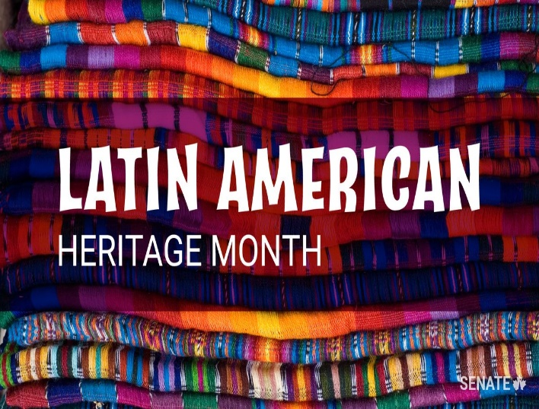October 7, 2022

Did you know the [Multicultural Calendar](https://multiculturalcalendar.com/ecal/index.php?s=c-okanag) can be accessed by all staff on the SD23 Dashboard in the Diversity, Equity and Inclusion tile?

This calendar features special occasions, events and holidays recognized by different communities. This month is **Latin American Heritage Month.**

It was proclaimed by the Parliament of Canada on June 21, 2018, this month is an opportunity for Canadians to recognize the valuable contribution of members of the Latin American community to this country’s social, economic, political and cultural fabric